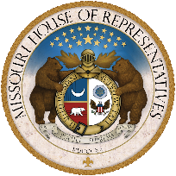
MISSOURI HOUSE OF REPRESENTATIVES
KATHY STEINHOFF DAVD TYSON SMITH ADRIAN PLANK DOUG MANN
STATE REPRESENTATIVE STATE REPRESENTATIVE STATE REPRESENTATIVE STATE REPRESENTATIVE
DISTRICT 45 DISTRICT 46 DISTRICT 47 DISTRICT 50

April 24, 2024

The Honorable Mike Parson
Governor of Missouri
Missouri Capitol, Room 216
Jefferson City, MO 65101

Governor Parson:

We, the Columbia Representatives of the Missouri House, are writing to respectfully ask you to veto SB 727. We are particularly concerned about the negative consequences it will have for our constituents and communities’ school districts. This bill narrowly passed the House by the bare minimum of 82 votes.

Foremost among our concerns is the section in SB 727 that allows for the establishment of new charter schools in Boone County. As representatives of this region, we have heard resounding opposition from our local schools and constituents regarding this portion of the bill. The expansion of charter schools in Boone County is strongly opposed because it will divert funding away from the Columbia Public School District and neighboring districts within our county, which are already facing significant financial challenges. When charter schools initially entered the conversation in Missouri, it was to address unaccredited school districts. None of our public schools in Boone County are unaccredited. It has never been made clear what problem we are trying to solve by creating Charter Schools in Boone County.

Within the Columbia Public School District, which is the largest in the county, 70 percent of graduates extend their education beyond high school, 10 percent achieve industry credentials while attending high school and more than 30 percent earn the College Preparatory Studies Certificate. Student performance on ACT and SAT exceed state and national averages. Columbia Public School District is also nationally ranked by Newsweek, District Administration magazine, US News and World Report, School Match, Niche, and the National School Boards Association.

Much of the support for this bill has been centered on the need for choice. There are plenty of choices for families within the Columbia Public School District. The district has three elementary schools and one middle school that are considered “lottery schools” and are application based. This is choice that is part of the fabric of our public school district. The district also has a Career Center that serves students throughout Boone County. None of the superintendents for these districts supports the addition of a charter school. Again, it has never been made clear what problem we are trying to solve by creating Charter Schools in Boone County.

Furthermore, we must address the misleading promises put forth by SB 727. While the bill alleges to invest in public education, raise teacher pay, and expand pre-K programs, it relies on future appropriations that are highly uncertain. The bill fails to tie any actual funding sources to these provisions, making it an unfunded mandate that will burden our local communities in the long run.

Governor Parson, we recognize your legacy of making fiscally responsible decisions and supporting our public schools. We respectfully ask you to consider the negative consequences this will have on our public school districts and our communities and ask you to say yes to our children and no to special interest groups, and veto this bill. We call on your leadership to prioritize the needs of our public schools and communities by rejecting measures that undermine public education and divert critical resources away from our students.

Thank you for your attention to this matter. We stand ready to work with you and other stakeholders to ensure that the interests of our constituents are adequately represented and protected.

Sincerely,

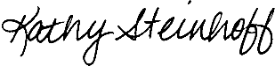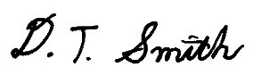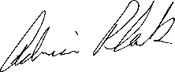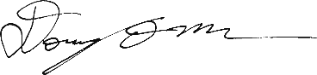

Kathy Steinhoff David Tyson Smith Adrian Plank Doug Mann
State Representative State Representative State Representative State Representative
District 45 District 46 District 47 District 50

