Synopsis
By the direction of the Chief of Police, I was tasked to review an incident from July 5, 2020 in the area of Volunteer Drive and Grace Lance. The incident started as a Fourth of July celebration with several adults and children participating. At some point, tempers flared resulting in the discharge of firearms with one child and one adult deceased and three other adults injured. During the incident there was a communication breakdown in the response by the Columbia Fire Department and ambulance services which I was asked to examine as part of this review.
Geographic location
The incident occurred in the northeast portion of Columbia where the neighborhood is made up of duplex-style homes. Volunteer Drive runs east to west. The roadway is 30 feet, 9 inches wide with cars commonly parked on both sides resulting in restricted single vehicle access. The crime scene area mainly consisted of the first four structures on Volunteer Drive as you enter from Grace Lane. Victims were located in the street, yards and in the residences.
Incident location. Source: Google Maps
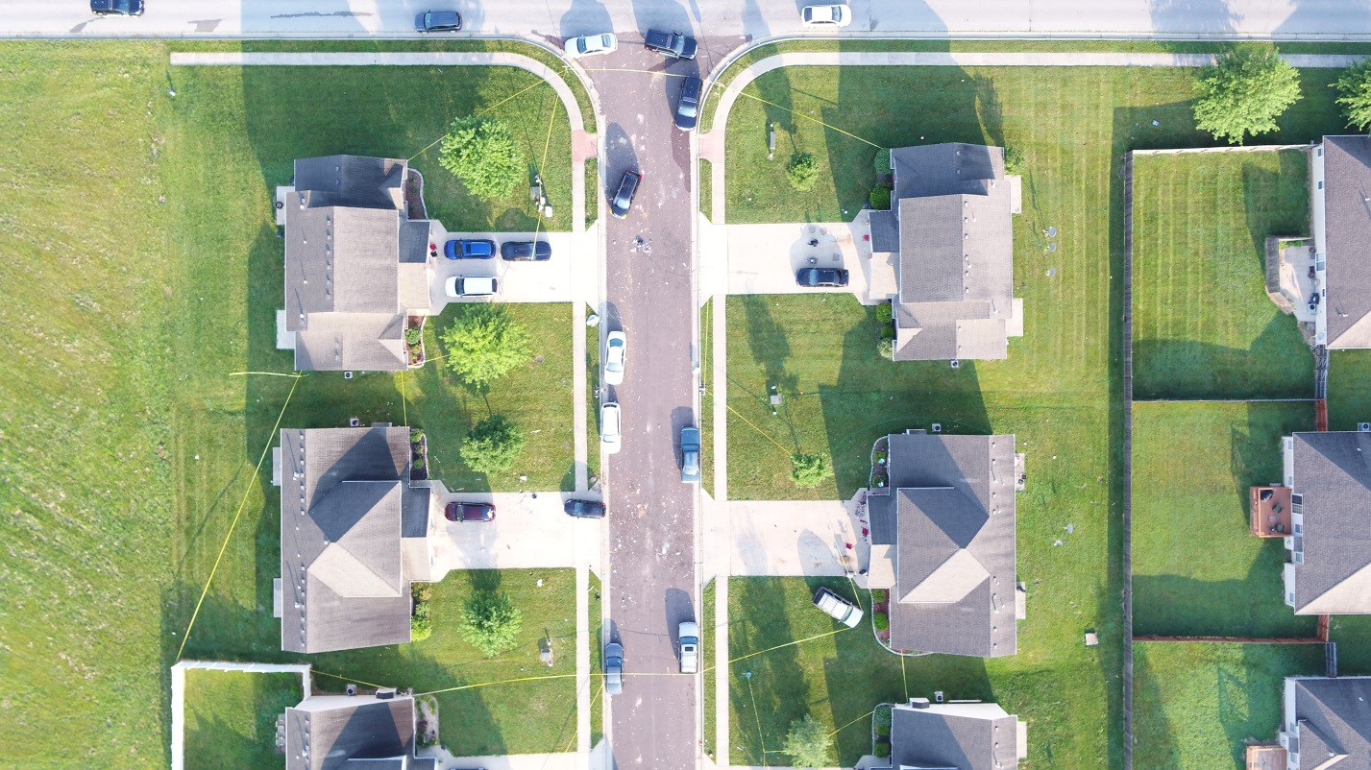
CPD drone overhead photo of the scene, July 5, 2020. Grace Lane at top of picture. Source: Google Maps
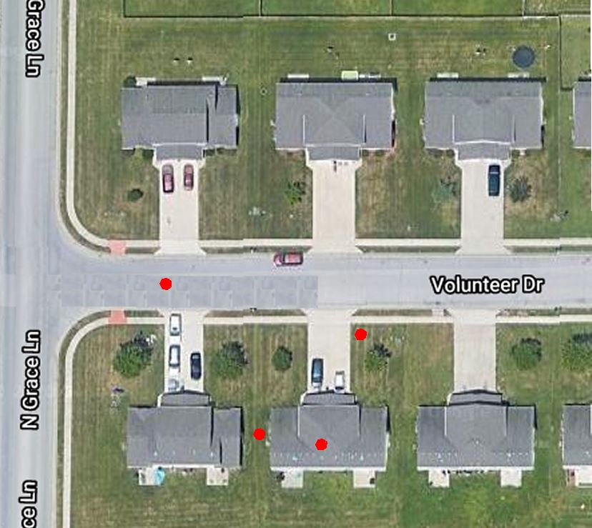
Red dots indicate where victims were located. Source: Google Maps
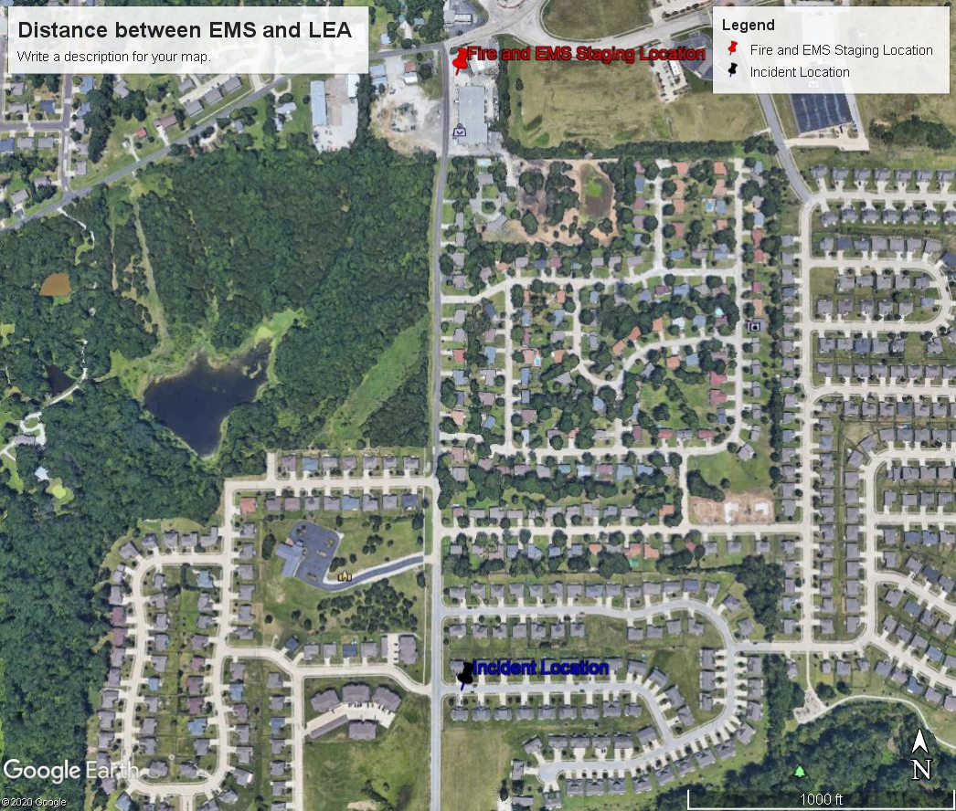
Distance between staged EMS/Fire and Police officers. Distance is .47 of a mile. Source: Google Maps

Assets assigned to call within the first 10 minutes
Columbia Fire Department = 2 Quint with 6 personnel, 1 Division Chief
University Hospital and Clinics = 2 ambulances with 4 personnel and 1 EMS Supervisor
Boone Hospital Ambulance = 1 ambulance with 2 personnel
Columbia Police Department = 3 sergeants, 1 Lieutenant, 14 officers
Law Enforcement Mutual Aid = 2 from Missouri State Highway Patrol, 19 from Boone County Sheriff’s Department

Incident overview
On July 5, 2020 at about 0023 hours, Boone County Deputies were in the area of Volunteer Drive. The deputies witnessed an apparent disturbance during which firearms were discharged. Columbia Police officers were dispatched, and a majority of officers working responded.
First arriving officers estimated the size of the crowd at about 100 persons and were immediately overwhelmed with people directing them to victims in several directions. One victim was a child who, after being removed from a vehicle, was placed on the street. Providing trauma care to the child took the first two arriving officers out of service attending to the child. Officers began to assess other victims and stabilize the scene, requesting medics various times during the incident. After what seemed a lengthy delay in response from EMS, the Main Law dispatcher stated EMS was not responding in (00.32.46). At that point, (00.33.23) officers began transporting on their own to University Hospital and Clinics Emergency Room, a Level 1Trauma Center. According to timestamps on the radio traffic, the incident started at 00.21.55 hours with the last victim arriving at the hospital at 00.42.19 hours (20minutes and 26 seconds).
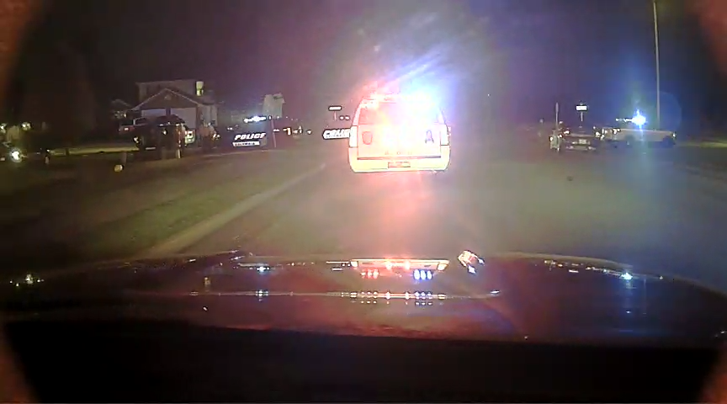
View of southbound Grace Lane @ Volunteer on July 5, 2020. Source: CPD
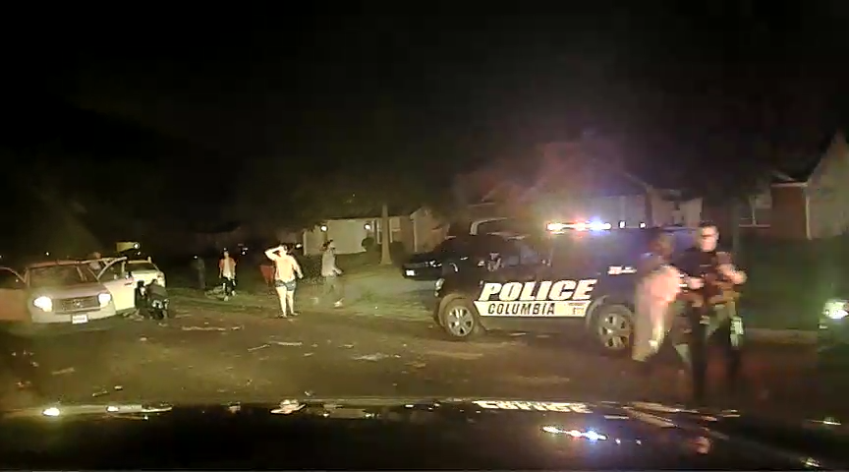
Parked eastbound on Volunteer at Grace Lane. July 5, 2020. Source: CPD
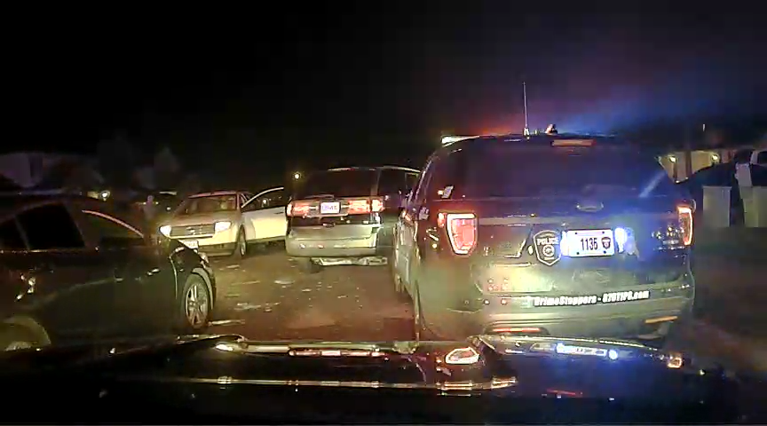
Street view Volunteer Drive looking east at Grace Lane intersection, July 5, 2020. Source: CPD

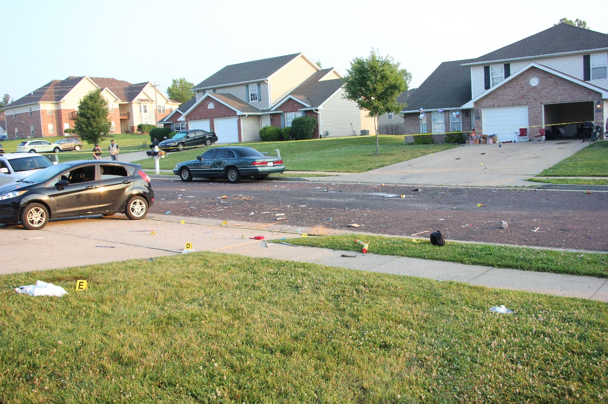
July 5, 2020 daytime view of Volunteer Drive looking northwest. Source: CPD
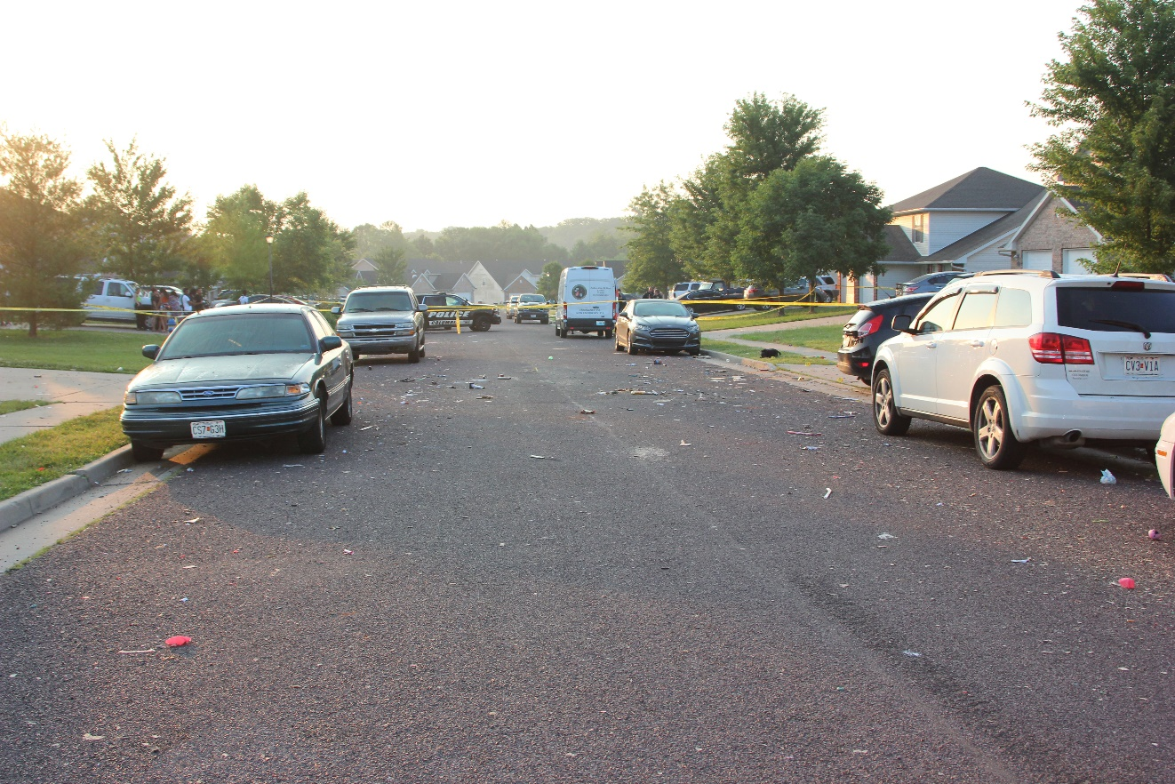
July 5, 2020 daytime view looking east from Grace Lance on Volunteer Drive. Source: CPD
Radio traffic breakdown and timeline (per CAD notes)
See attached spreadsheets.
Incident debrief on July 9, 2020
On July 9 at 1500 hours, members of the Columbia Police Department, Columbia Fire Department, Boone Hospital Center, University Hospital Emergency Services and Boone County Joint Communications met to discuss the incident. The review started by listening to the Main Law radio traffic and then the Fire/EMS radio traffic in its entirety.
In general terms, Columbia Fire Department and the ambulance services were not notified the incident was safe for them to respond in until 00.33.15. In reviewing the radio transmission, officers requested medics at least four times prior to that time stamp.
Although I believe our communications were clear enough and reinforced by the comments by citizens on social media, we all agreed to clearer communications.
Additionally, Boone County Joint Communications could not provide an explanation as to why the information from the Main Law console was not getting to the Fire Console and then repeated out. Several times law enforcement requested medics to respond in, yet that message was not conveyed. When asked why the Main Law dispatcher stated they (fire and ambulances) refused to come into the scene, Boone County Joint Communications management stated it was an assumption of the Main Law dispatcher, but have not spoken in detail with them about the this event yet.
At the conclusion of the meeting, it was determined more research/conversations into what happened were needed (scheduled for July 23rd, 2020)
As a stopgap, the Columbia Police Department immediately implemented the following changes taken directly from my email to all staff:
“ 1. Cross radio monitoring and traffic is encouraged to ensure accurate direct communications. What does cross radio traffic mean? It means if you need to speak to CFD or EMS go to Columbia Fire freq and CFD/EMS may talk to you on Main Law or CPD 2.
2. On all incidents involving violence we need to provide clear communications the scene is stable. We have gotten away from clear communications over time which has added to confusion. Do not assume others understand your traffic, be clear "Scene is stable for EMS". EMS understands there may be yelling and other distractions. They are not naive to what these scenes look like.

3. All criminal incidents with injuries and medics are coming an officer or commander on scene will determine a CCP (casualty collection point). The CCP should be announced over the radio. The CCP may be something as simple as a house or in the driveway, larger active scenes like Volunteer Dr need to be outside of the hot zone. We'd like you to use this for all calls where medics are en route so it becomes second nature.”

Areas of strength (no specific order)
- Officers were already on a heightened level of awareness given the recent protest; recent shot fired calls and this being the Fourth of July. As the call evolved into shots fired, officers were already in route reducing response times.
- The request by Sgt. German to ask for mutual aid resulted in a rapid response of 19 deputies and two troopers.
- Officers identified the suspects and seized weapons early in the event.
- Officers located victims quickly and began providing them with trauma care.
- Once the decision was made to transport victims, officers transported them quickly.
- Shift Training sessions worked. Officers stated that, during the event, they recalled what Sgt. Brunstrom taught them about trauma care.
- Officers used different de-escalation techniques to keep the crowd calm, as best they could.
- Community members were understandably upset but cooperated with officers to provide aid to victims.
- Community members were assisting officers with patient care and providing towels.
- Officers recalled prior training and kept Grace Lane open for responding EMS/Fire.
- Because of our working relationship with BCSD, the arriving deputies did as requested without hesitation.
- Post-incident, sergeants and officers checked on each other physically and emotionally. Tactical and emotional debriefs occurred in a timely manner. No officers were injured.
Areas of improvement/suggestions (no specific order)
- Emergency Services in Columbia/Boone County should train together often. Day-to-day operations run smoothly. It’s incidents like the one on July 5…larger scale, infrequent, requiring heavier command and control…where we should focus improvements. Training should involve frontline personnel. Face-to-face interaction will build trust and closer working relationships.
- The Columbia Police Department should continue to train frontline supervisors and middle management in the Incident Command System (ICS). Fire and EMS use ICS daily, and during this incident it was unclear on radio traffic who on Law was in charge. If ICS had been implemented early, command and control would have been easier to maintain, and I believe communication would have been better.
- As difficult as this is, officers need to focus on their primary duties of securing the scene and eliminating threats. This may require officers to bypass injured victims. Multiple videos showed officers with trauma bags in their gun hands or concentrating on victim care instead of their surroundings. This has been noted on incidents in the past and should be an alarm. There is a careful balancing act, but it is necessary to ensure everyone’s safety.
- Not being overly critical of the officers on this incident as there are too many factors involved. Through training and reinforcement, we should encourage officers to transport victims only when the time saved and distance to hospital is beneficial to the victim. Compare, for example, a person shot Downtown with no activation of fire or EMS to this incident, where advanced life support is a half-mile away and a hospital is a great distance.
- Working with the hospital, develop policy and training outlining the officer’s responsibilities with a deceased victim within a hospital setting and the legal obligations of hospital staff.
- In surveying officers, most have not had formal training on the trauma bags. Prior to COVID-19 we had plans for a contracted instructor to teach trauma care along with civilian/officer rescues a part of our external continual education requirements. Those plans should move forward.
- Most officers have not had active incident/shooter training. I believe that training would be beneficial to the officers in their decision-making and in prioritizing their actions. This could assist with suggestion #1 if we move it to an all-county training exercise.
Equipment Requests
A request was made to have reusable soft stretchers added to each vehicle to help with movement of victims. In basic research, they appear to be about $30.00 each or $1,500 for an adequate supply.
Officers requested more wound packing material in the trauma bags, expected to cost under $400.
Officers state they are seeing more firearm incidents involving rifle rounds that can penetrate the issued vest. Officers request we consider purchasing protective equipment or allow them via policy to purchase plates on their own. Pricing and set-ups would require research.
Attachments:
Radio traffic from Main Law, CPD 2, EMS and Columbia Fire (USB jump drive)
CAD notes of the call

