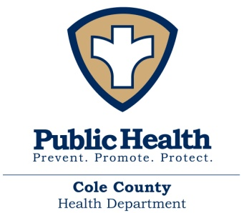
FOR IMMEDIATE RELEASE – April 21, 2020
Cole County Health Department will not extend local Stay at Home Order
As of 8:00 am today, there have been a total of 45 cases of COVID-19 in Cole County. Nine are active cases, and 35 are recovered cases. Cole County Health Department staff has been able to complete contact investigations on each case. The majority of the cases in Cole County are travel related or close household contacts of a positive case.
The community’s cooperation with the Stay at Home orders has allowed the healthcare system in Cole County to care for patients and not become overwhelmed beyond their capacity.
Cole County’s current Stay at Home Order will expire on April 25, 2020 at 12:01 PM. As Cole County’s first step into a recovery phase, the Cole County Health Departments recommendation is to not extend the local restrictions in Cole County’s Stay at Home order. In addition, the establishment order that pertains to restaurants, bars and clubs from March 19th will be rescinded effective today.
Cole County would then still be under the Governor’s Statewide Stay at Home order which directs all Missourians to avoid leaving their residences unless necessary and to practice social distancing when they need to go out to complete essential activities. Essential activities include going to work, to the grocery, convenience, or warehouse stores, going to the pharmacy and medical appointments, getting food from restaurants, receiving deliveries, and getting outside to exercise.
Businesses that do not qualify as essential businesses can be open as long as they are complying with the social gathering and physical distancing requirements. Those requirements are no more than 10 individuals can occupy a single space, this includes both employees and customers. Individuals must also maintain at least 6 feet of distance between themselves and others.
On April 16th, Governor Parson extended the statewide Stay at Home order for Missouri until May 3, 2020. The Governor also explained that the statewide approach to recovery will be deliberate and data-driven with two initial phases intended to protect those most at risk of exposure to COVID-19 while returning Missouri to a new normal.
We anticipate that there may be an increase in positive cases as specific restrictions are lifted. After consultation with both major healthcare systems in Cole County, they have reported adequate capacity and testing capabilities.
We still advise the community to do everything they can to protect themselves and others. Stay home if you are sick, wash your hands, use hand sanitizer, and physically distance from others.
We still need to be vigilant and keep up the precautions while we relax restrictions. The Cole County Health Department will continuously monitor our caseload and reevaluate. Our staff will continue to investigate positive cases and conduct the necessary contact tracing. If we have an unmanageable increase in positive cases or an outbreak that causes the local healthcare system to become overwhelmed, we will reevaluate at that time.
###

