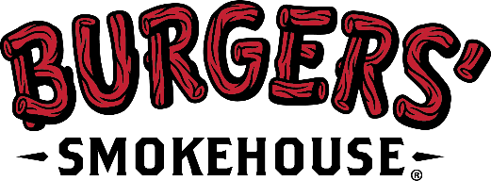

- Updated For Immediate Release-
Media Contact: Kelly Perrier
Phone: 316-737-9847
Email: kperrier@smokehouse.com

California, MO (April 15, 2020) – On the morning of Wednesday, April 15, Burgers’ Smokehouse was notified that two more employees had tested positive for COVID-19 for a total of three confirmed cases. Others known to be in close contact with those testing positive have also been tested and are awaiting results. The company continues to work closely with the Moniteau County Health Center to contain the spread.
With the updated results & after careful consideration, Burgers’ Smokehouse believes the most appropriate course of action is to close the California, MO plant until Monday, April 20. During the closure, further efforts will be made to reduce the number of people in our production areas and break rooms at one time to allow for increased social distancing. Additionally, efforts are underway to continue to buy more face masks and require more stringent wellness screening before being allowed to report to work.
“We take our responsibility as part of the nation’s critical infrastructure seriously and will make every prudent effort to remain in operation during this ongoing crisis; however, we feel it is important to shut down for a few days in order to further prepare our facility for the safe return of our people on Monday,” said, Steven Burger, President, Burgers’ Smokehouse. “We continue to offer our prayers to those affected by the COVID-19 virus and look forward to the day when all of our employees are able to return to work.”
About Burgers’ Smokehouse & subsidiaries
Burgers’ Smokehouse has been the trusted provider of wholesome & authentic specialty meats and foods since 1927. They are the largest producer of country ham, including cooked country ham, in the U.S. selling under the Burgers’ Smokehouse, Clifty Farm Country Meats & Hobe’s Country Ham brands. The company additionally sells smoked & sugar-cured hams, dry cured bacon, smoked poultry, summer sausage, and over a dozen more specialty meat items to grocery stores, restaurants, and directly to consumers through mail order and e-commerce. To learn more visit www.smokehouse.com.
###

