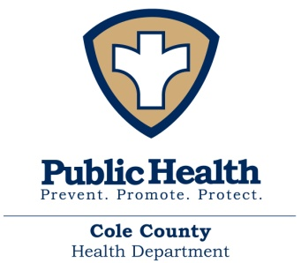

FOR IMMEDIATE RELEASE – March 18, 2020
Second Case of COVID-19 in Cole County
COLE COUNTY, MO – The Cole County Health Department has confirmed its second positive case of COVID-19 in Cole County. Although, the patient’s identity will remain confidential, we can say that this was a travel related case. We will not be releasing any personal information about this case.
The person has been notified that they have tested positive for COVID-19. We are working with this individual to insure they are following Missouri Department of Health and Senior Services (DHSS) and Centers for Disease Control and Prevention (CDC) guidelines in regards to isolation.
The Cole County Health Department is currently working with this individual to identify close contacts in order to monitor them for symptoms and contain spread. If you are identified as a potentially exposed person, you will be contacted by the Cole County Health Department.
The Cole County Health Department is taking necessary precautions to keep our patients and community safe and will continue to diligently monitor the COVID-19 situation and follow CDC guidelines to help protect the public health and limit spread of this infection.
It is important that each and every one of us continue to practice basic preventative measures to help decrease the spread. These measures, as outlined by the CDC, include: avoiding contact with people who are sick, covering coughs and sneezes, proper hand-washing, cleaning frequently used surfaces, and staying home when sick.
We highly encourage, if you suspect that you have COVID-19 or have been exposed to someone with COVID-19, call your healthcare provider before seeking care.
********

