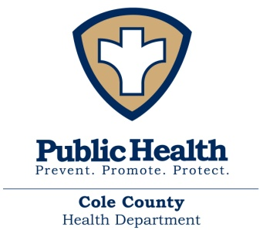

FOR IMMEDIATE RELEASE – March 20, 2020
Cole County Health Department announces additional case of COVID-19
COLE COUNTY, MO – The Cole County Health Department has confirmed its third positive case of COVID-19 in Cole County. The patient’s identity will remain confidential; therefore, we will not be releasing any personal information about this case.
The Cole County Health Department has notified this individual and we are working to insure they are following DHSS and CDC guidelines in regards to isolation. We are also working to identify close contacts in order to monitor them for symptoms and contain spread.
It is important that each and every one of us continue to practice basic preventative measures to help decrease the spread. These measures, as outlined by the CDC, include: avoiding contact with people who are sick, covering coughs and sneezes, proper hand-washing, cleaning frequently used surfaces, and staying home when sick.
The Cole County Health Department is taking necessary precautions to keep our patients and community safe and will continue to diligently monitor the COVID-19 situation and follow CDC guidelines to help protect the public health and limit spread of this infection.
We highly encourage, if you suspect that you have COVID-19 or have been exposed to someone with COVID-19, call your healthcare provider before seeking care.
As more cases are reported to CCHD, we will update the COVID-19 cases at www.colehealth.org each day by noon.
If you have questions, please consult a factual source, such as www.health.mo.gov/coronavirus or www.CDC.gov. The community can also call MDHSS 24-hour hotline (877)435-8411 or CCHD to address questions or concerns related to COVID-19.
###

